

EXAMINATION FOR MEMBERSHIP

WRITTEN PAPER

Tuesday 24 October 2006

REFERENCE MATERIAL FOR QUESTIONS 3, 4 and 6
Reference material A – Question 3

Psychological treatment for insomnia in the management of long-term hypnotic drug use: a pragmatic randomised controlled trial.

Method

The study was approved by the North Sheffield Research Ethics Committee. General practices were eligible to participate if they were not currently running a benzodiazepine reduction programme and were able to provide a suitable room for psychological treatment. From 96 general practices in the Sheffield area we randomly selected 42, and of these 23 met the study criteria and agreed to participate.

Patients were eligible for the trial if they: had been consuming hypnotics for at least the previous month; were not taking neuroleptic medication; were requesting or due for a repeat hypnotic prescription; and were able to travel to the surgery for appointments. To ensure adequate representation of older patients (the most likely consumers of long-term hypnotics), and to exclude those (generally younger adults) whose sleep disturbance is often lifestyle-related, the selection criteria also included a lower age of 30 years, but no upper age limit.

Psychological treatment was provided by experienced primary care counsellors following 40 hours of classroom based training in cognitive-behavioural approaches to insomnia management. The counsellors were recruited from outside the Sheffield area, and worked exclusively for this project. Treatment sessions were offered on a weekly basis within the surgery of the referring doctor at a time convenient for the patient.

Reference material B – Question 4

Psychological treatment for insomnia in the management of long-term hypnotic drug use: a pragmatic randomised controlled trial

Trial outcomes were: Pittsburgh global scores (range 0–21 with lower scores indicating reduced severity of sleep disturbance); the Pittsburgh component scores ‘total sleep time’ (estimated actual sleep per night), ‘sleep efficiency’ (percentage of time in bed spent asleep), and ‘sleep latency’ (time taken to get to sleep); SF-36 scores; frequency of hypnotic drug use (as a percentage of baseline value); healthcare costs and cost utility. Additional outcomes included the number of hypnotic drugfree nights per week, and the mean hypnotic dose (expressed as a percentage of the maximum dose prescribed).

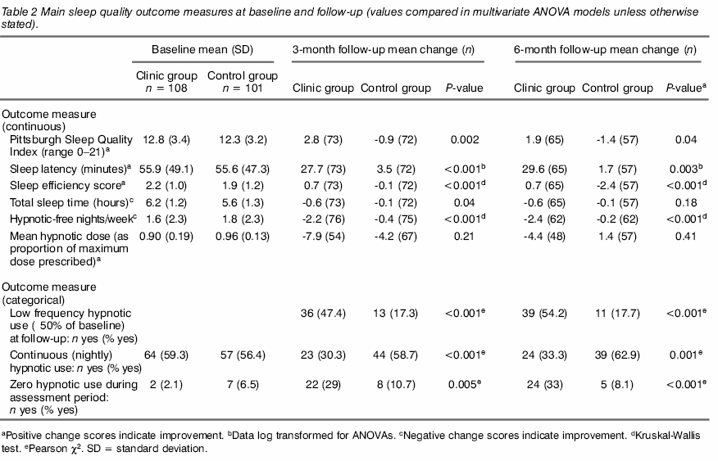

Table 3 Costs (in £) from baseline to 3-month
Reference material C – Question 6

Antidepressant treatment and the risk of fatal and non-fatal self harm in first episode of depression: nested case-control study.
Method
The General Practice Research Database contains anonymised clinical records from primary care in the United Kingdom.⁹ Our study cohort came from this database and comprised patients aged 90 years or younger with a first recorded prescription for antidepressants between 1 January 1995 and 31 December 2001. The date of the first prescription defined entry to the cohort. Members of the cohort were required to have contributed a minimum of 365 days to the database before their first recorded prescription for antidepressants and to have received a diagnosis of depression in the 180 days before or 90 days after entry to the cohort. Follow up ended with the earliest of either an episode of suicidal behaviour, the end of the first treatment episode, the end date of the study, or when the patient left the practice.
We identified depression by a set of Read and Oxford Medical Information System (OXMIS) medical terms indicative of depression, bipolar disorder, or dysthymic disorder. We classed severity of depression as mild, moderate, or severe.
We studied the two outcomes of non-fatal self harm and suicide. We identified cases of suicide from a list of OXMIS or Read medical terms, review of all free text entries for patients who had died of any cause, and death certificates when available (around 60% of cases). Using this information we assessed the likelihood, the method, and the date of suicide.
We identified cases of non-fatal self harm (drug overdose, deliberate self laceration, poisoning, and non-fatal suicide attempts using other methods) by using relevant OXMIS or Read medical terms and review of the patient's free text notes.
We selected a random sample of up to 20 controls for each case from the cohort, matching for sex and year of birth within one year. We derived the duration of prescriptions from the quantity of drug prescribed and the daily dose plus an additional seven day washout period.
Table 6. Risk of non-fatal self harm in people prescribed SSRIs compared with tricyclic antidepressants in relation to age
 | Non-fatal self harm
Exposure | Cases (n=1344) | Controls (n=19 953) | Crude odds ratio (95% CI) | Adjusted odds ratio* (95% CI)
10-18 years:
Any current use of tricyclic antidepressants | 24 | 493 | 1 | 1
Any current use of SSRIs | 168 | 2148 | 1.73 (1.10 to 2.72) | 1.59 (1.01 to 2.50)
19-30 years:
Any current use of tricyclic antidepressants | 106 | 1687 | 1 | 1
Any current use of SSRIs | 312 | 5013 | 1.00 (0.79 to 1.27) | 1.04 (0.82 to 1.32)
>30 years:
Any current use of tricyclic antidepressants | 189 | 2721 | 1 | 1
Any current use of SSRIs | 374 | 6475 | 0.83 (0.69 to 1.01) | 0.86 (0.71 to 1.04)

Participants exposed to more than one antidepressant or prescribed non-SSRI, non-tricyclic antidepressants were included in models but, for presentational purposes, data are not given in table.

* Adjusted for severity of depression; time depression was diagnosed in relation to start of therapy; referral to psychiatrist or psychologist before index day; history of self harm; diagnosis of, or treatment for, anxiety or panic disorder; schizophrenia; antipsychotic drugs; drug misuse, and alcohol misuse.

Includes nine cases of non-fatal self harm and 86 controls exposed to SSRIs, and no cases and 18 controls exposed to tricyclic antidepressants among patients aged 10 to 14 years.

Figure 1 overleaf
Figure 1
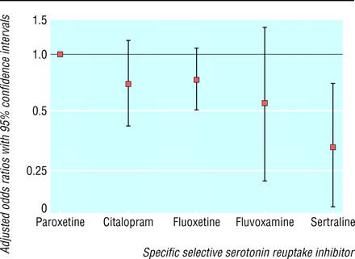

Fig 1 Risk of non-fatal self harm in patients aged 10-18 currently exposed to citalopram, fluoxetine, fluvoxamine, and sertraline compared with paroxetine

